Abstract Factory Design Pattern

Define an abstract class creating families of related object but without specifying their concrete sub class

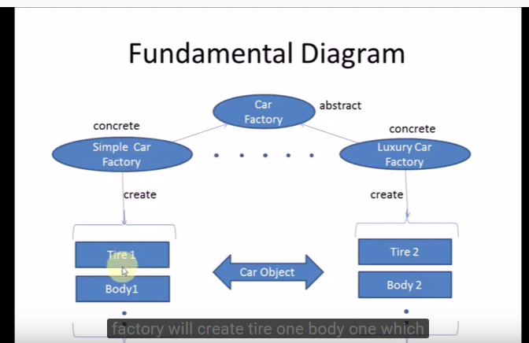

Builder Design Pattern – Creating Object with composing complex object and director will handle that

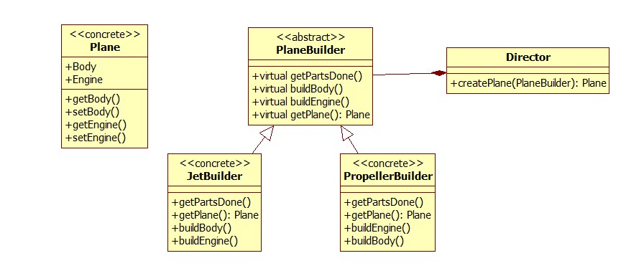
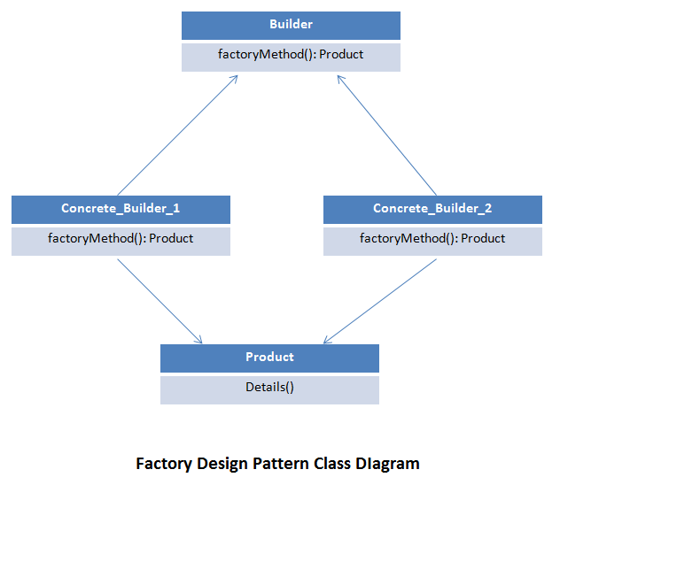

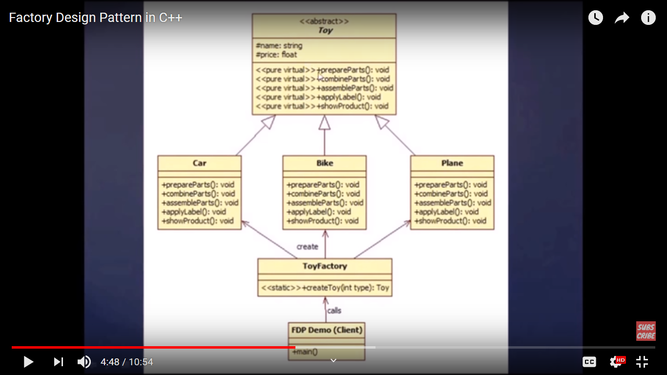
Factory Design Pattern:
It create object intialized object , It kind of virtual constructor

Singleton Design Pattern
It will create only one instance of object
- Private Constructor
- Static Member variable
- static member function

Object Pool
Object pooling can offer a significant performance boost; it is most effective in situations where the cost of initializing a class instance is high, the rate of instantiation of a class is high, and the number of instantiations in use at any one time is low.
class ObjectPool
{
private:
std::list<Resource*> resources;

static ObjectPool* instance;
ObjectPool() {}
public:
/**
* Static method for accessing class instance.
* Part of Singleton design pattern.
*
* @return ObjectPool instance.
*/
static ObjectPool* getInstance()
{
if (instance == 0)
{
instance = new ObjectPool;
}
return instance;
}
/**
* Returns instance of Resource.
*
* New resource will be created if all the resources
* were used at the time of the request.
*
* @return Resource instance.
*/
Resource* getResource()
{
if (resources.empty())
{
std::cout << "Creating new." << std::endl;
return new Resource;
}
else
{
std::cout << "Reusing existing." << std::endl;
Resource* resource = resources.front();
resources.pop_front();
return resource;
}
}
/**
* Return resource back to the pool.
*
* The resource must be initialized back to
* the default settings before someone else
* attempts to use it.
*
* @param object Resource instance.
* @return void
*/
void returnResource(Resource* object)
{
object->reset();
resources.push_back(object);
}
};
ObjectPool* ObjectPool::instance = 0;
int main()
{
ObjectPool* pool = ObjectPool::getInstance();
Resource* one;
Resource* two;
/* Resources will be created. */
one = pool->getResource();
one->setValue(10);
std::cout << "one = " << one->getValue() << " [" << one << "]" << std::endl;
two = pool->getResource();
two->setValue(20);
std::cout << "two = " << two->getValue() << " [" << two << "]" << std::endl;
pool->returnResource(one);
pool->returnResource(two);
/* Resources will be reused.
* Notice that the value of both resources were reset back to zero.
*/
one = pool->getResource();
std::cout << "one = " << one->getValue() << " [" << one << "]" << std::endl;
two = pool->getResource();
std::cout << "two = " << two->getValue() << " [" << two << "]" << std::endl;

return 0;
}

Prototype Design Pattern
Creating Object is expensive operation as compare to copying the object

return always cloned object
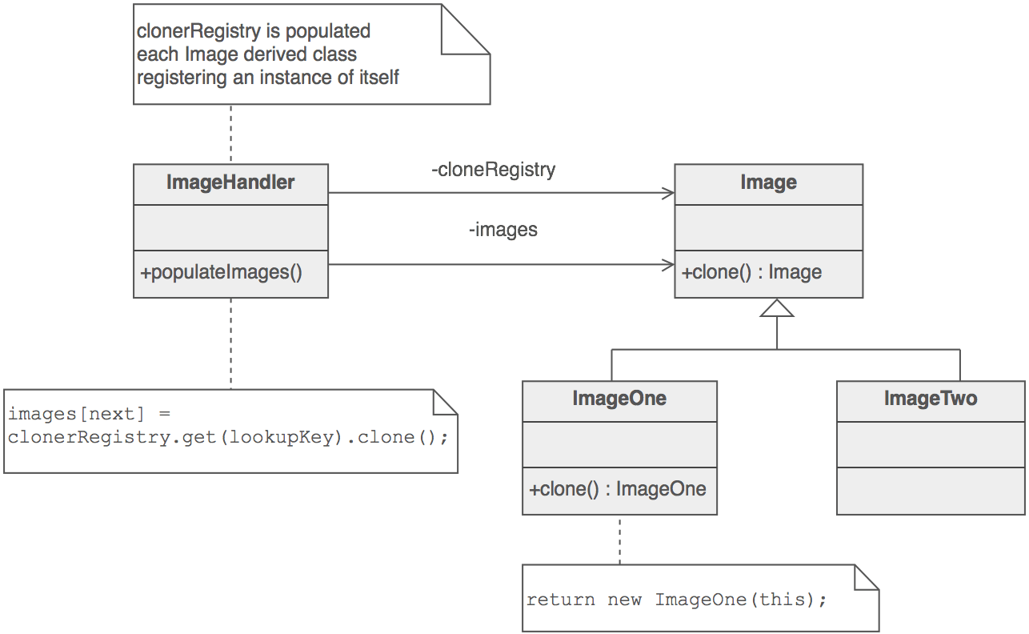

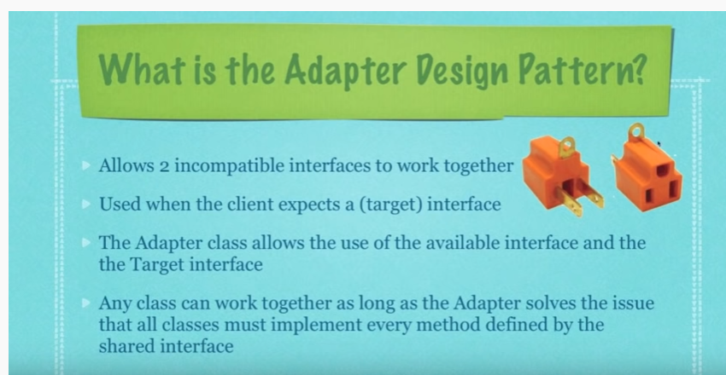
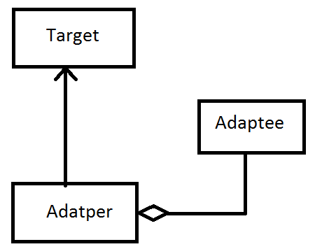

adapterPattern.txt

Bridge Pattern (Structural Pattern)
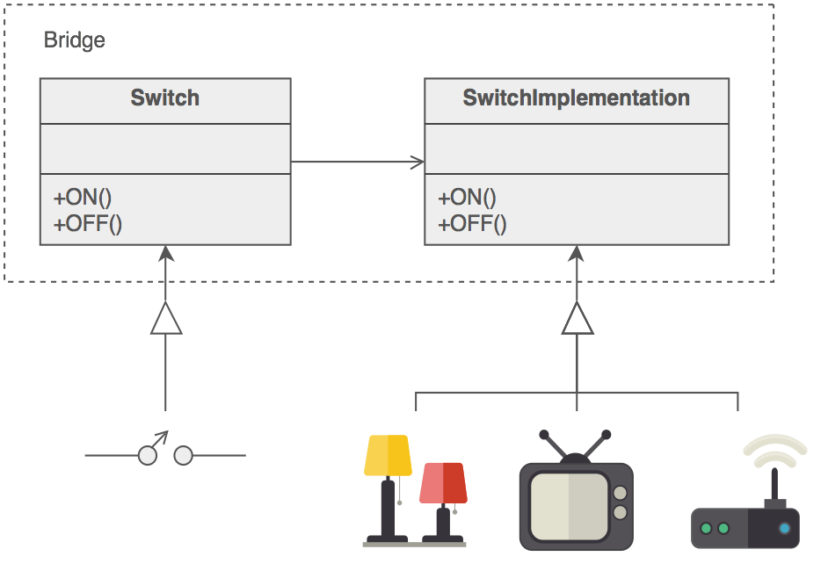

Startegy Pattern (Behavioral Pattern )

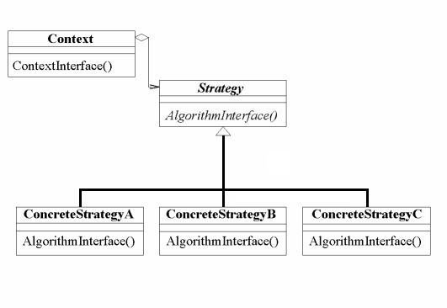

Template Design Patter (Behavioral Pattern)

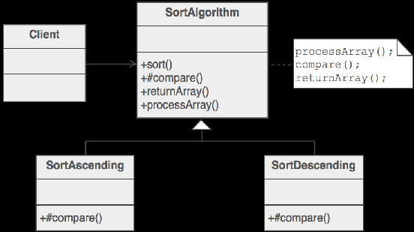

Decorator Pattern (Structural Pattern)

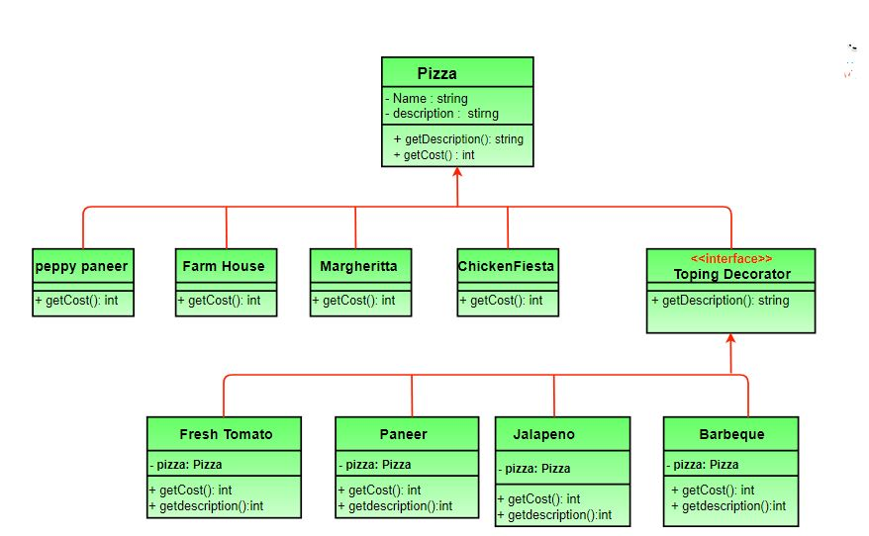
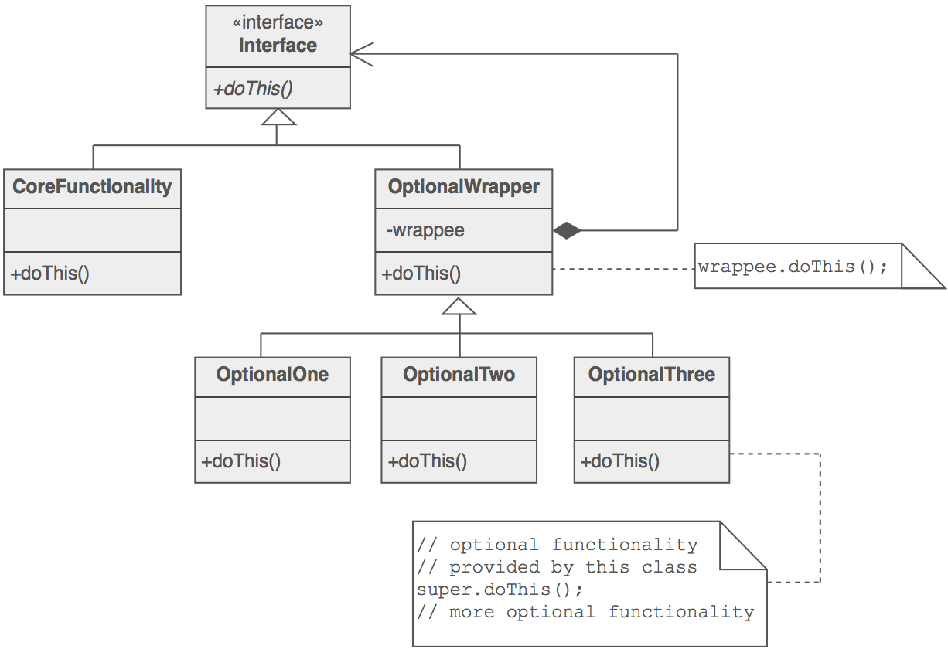

Composite Pattern (SP)

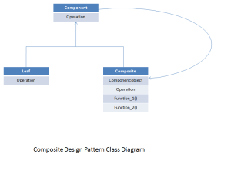

Fly Weight Pattern (SP)

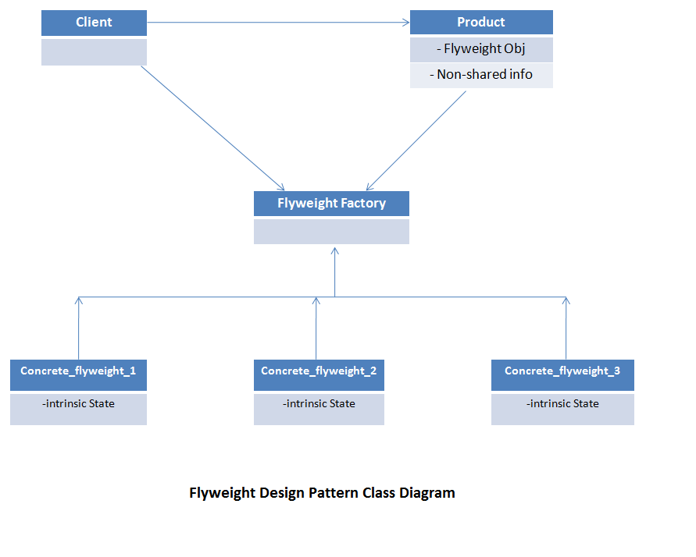
Facade Pattern (SP)
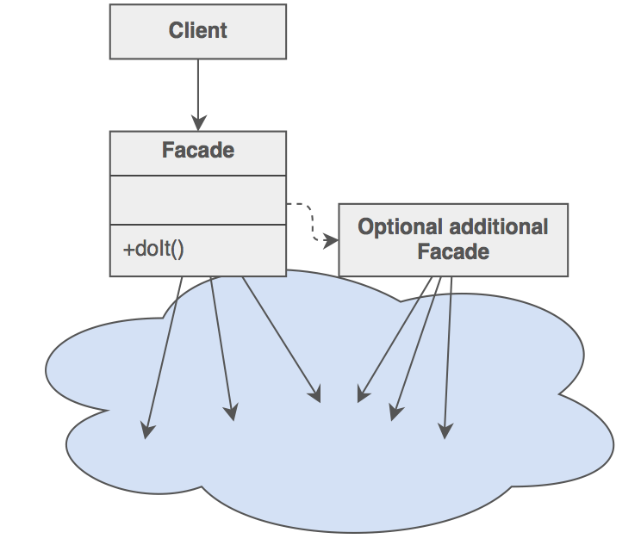

Proxy Pattern (SP)

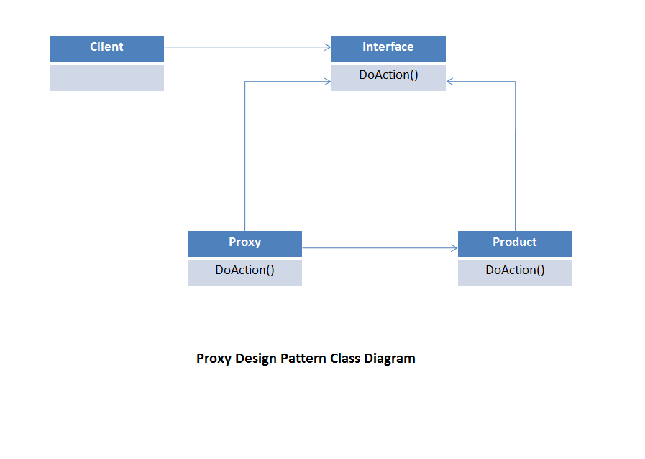

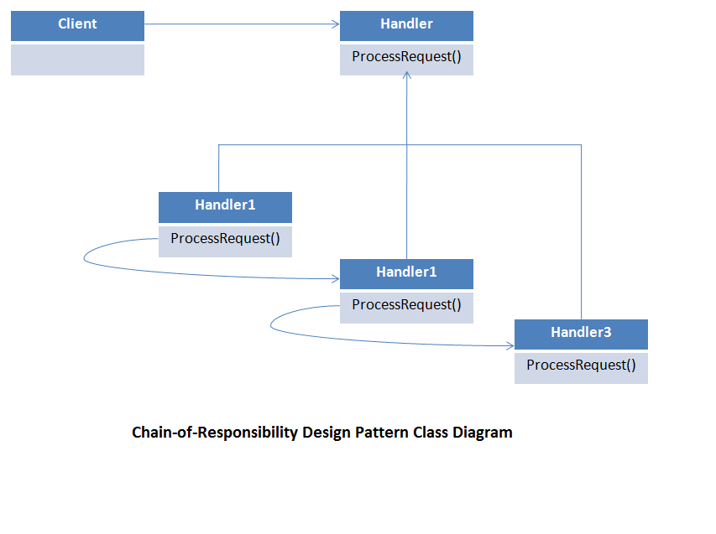
Chain of Responsibility

